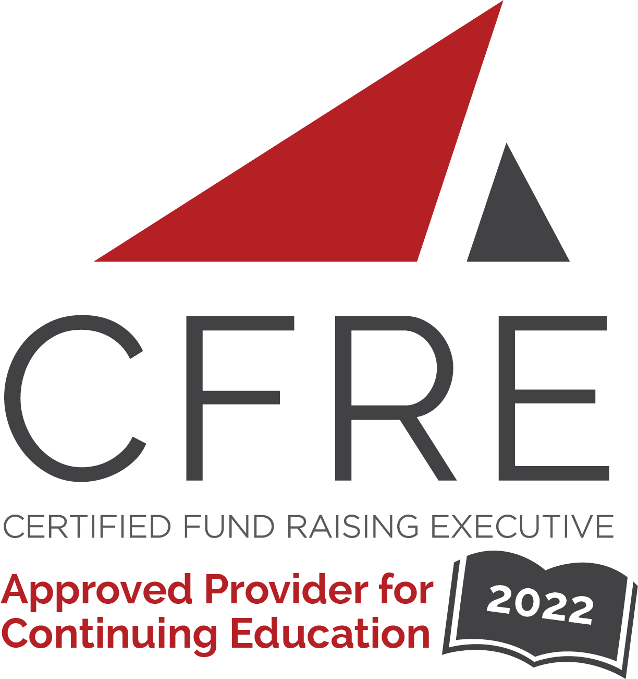  CFRE International has developed this form as a way for you to quickly track (and keep in your files!) the continuing education sessions you have attended. Simply check the boxes next to the sessions you attended. At the end of the conference, add up the total number of hours. Keep this sheet and you will be ready to complete your application form. All of the session slots listed are eligible for continuing education points on your CFRE application for initial certification and/or recertification. Sessions not listed here are not eligible for points. |  | CONTINUING EDUCATION POINTS TRACKER

Activity Organizer: - ALDE and TNPA CDC
Title of Activity: - Faith & Fundraising Conference
Names of Presenter(s): - Various
Dates and Location: - February 22 – 25, 2022, Milwaukee, WI

Date: Tuesday, February 22, 2022
Session 1: 12:00 [pm] – 4:00 [pm] (4 pts)
- [Leading Through Change]
- [Great Fundraising Foundations]

Date: Tuesday, February 22, 2022
Keynote: 6:00 [pm] – 7:00 [pm] (1 pt)
- [Andy Bales]

Date: Wednesday, February 23, 2022
Session 1: 10:00 [am] – 11:30 [am] (1.5 pts)
- [State of Modern Faith-Based Fundraising: Sustainer Giving]
- [New Technologies in Fundraising: Analytics, AI, and Digital]
- [Exploring Multigenerational Generosity]
- [Rightly Ordered. The Joy of Fundraising for Benefactor, Organization, and Your Well-Being]
- [The Wow, Now, and How of Planned Giving]
- [Turning a Battleship: How a Mature Christian Nonprofit Kickstarted its Declining Donor Database]

Date: Wednesday, February 23, 2022
Keynote: 12:00 [pm] – 1:00 [pm] (1 pt)
- [Krish O’Mara Vignarajah]

Date: Wednesday, February 23, 2022
Session 2: 1:30 [pm] – 3:00 [pm] (1.5 pts)
- [The Process-Driven Annual Fund]
- [The Current State of Donor Retention & What You Can Do About It]
- [Case Study: A Transformational Capital Campaign]
- [Why Love Bequests? How Do I Encourage More?]
- [Surviving & Thriving In a Leadership Transition]
- [Predictive Modeling: Where & How to Invest & Grow Your Fundraising]

Date: Wednesday, February 23, 2022
Session 3: 3:30 [pm] – 5:00 [pm] (1.5 pts)
- [Appeal Segmentation & Variable Messaging]
- [Can a Digital Marketing Campaign Be Too Successful?]
- [Grant Writing Workout]
- [When the Saints Come Marching In… So Do Major Donors]
- [Helping Donors Make Their Best Gifts: The Power of a Gift Planning Approach]
- [It’s Okay to be Q.U.I.E.T.]

Date: Thursday, February 24, 2022
Keynote: 8:30 [am] – 9:30 [am] (1 pt)
- [Tyrone Freeman]

Date: Thursday, February 24, 2022
Session 1: 10:00 [am] – 11:30 [am] (1.5 pts)
- [Monthly Giving. It Takes Just a Bit More Than Faith Alone]
- [Navigating Faith-Based Fundraising in a Digital World]
- [The Role of Race in Fundraising: Continuing the Conversation w/Dr. Tyrone Freeman]
- [The Anatomy & Process of Major & Principal Gift Fundraising]
- [Gratitude: A Crucial Part of Your Fundraising Plan]
- [Living on Both Sides]

Date: Thursday, February 24, 2022
Session 2: 2:00 [pm] – 3:30 [pm] (1.5 pts)
- [How Texting & Voice Broadcasting Changed the Game for Nonprofits During a Global Pandemic]
- [Let’s Throw a Party!]
- [Diversity Donors: Why & How to Engage with Them]
- [From Crisis Crucible to Program Growth: Partnerships That Raise Long-Term Support]
- [Understand Your Donors’ Brains to Get Better Results]

Date: Thursday, February 24, 2022
Session 3: 4:00 [pm] – 5:30 [pm] (1.5 pts)
- [Growing Up: Best Practices for Donor Acquisition]
- [Evoking a Response: Storytelling Techniques That Drive Revenue Growth]
- [Breakthrough: Simple but Overlooked Strategies That Help Fundraisers Raise More Money]
- [Live With Intention] NFR
- [Growing Recurring Giving in Today’s Subscription Economy]
- [Session Title]

Date: Friday, February 25, 2022
Keynote: 9:00 [am] – 10:00 [am] (1 pt)
- [Don Senior]

Total number of points attained: __________

