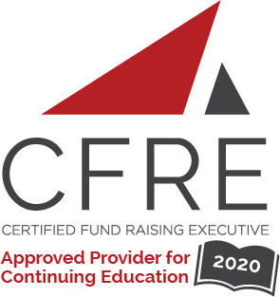  CFRE International has developed this form as a way for you to quickly track (and keep in your files!) the continuing education sessions you have attended. Simply check the boxes next to the sessions you attended. At the end of the conference, add up the total number of hours. Keep this sheet and you will be ready to complete your application form. All of the session slots listed are eligible for continuing education points on your CFRE application for initial certification and/or recertification. Sessions not listed here are not eligible for points. |  | CONTINUING EDUCATION POINTS TRACKER

Activity Organizer: - ALDE Heartland Chapter
Title of Activity: - Charitable Impact of the Secure Act and Cares Act in 2020 and Beyond
Names of Presenter(s): - Stacey Hall
Dates and Location: - 6 November, 2020, Online

Date: 6 November, 2020
1:00 pm – 2:00 pm (1.0 pts)
- Charitable Impact of the Secure Act and Cares Act in 2020 and Beyond

Total number of points attained: __________

