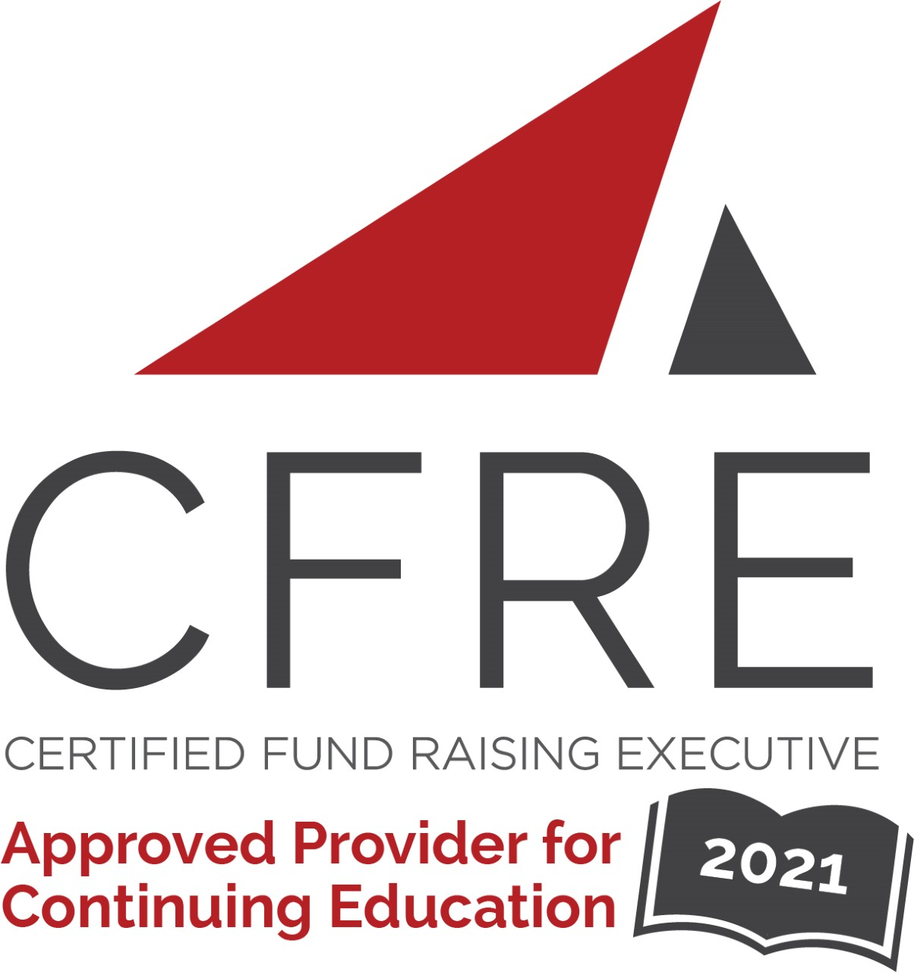  CFRE International has developed this form as a way for you to quickly track (and keep in your files!) the continuing education sessions you have attended. Simply check the boxes next to the sessions you attended. At the end of the conference, add up the total number of hours. Keep this sheet and you will be ready to complete your application form. All of the session slots listed are eligible for continuing education points on your CFRE application for initial certification and/or recertification. Sessions not listed here are not eligible for points. | CONTINUING EDUCATION POINTS TRACKER

Activity Organizer: - ALDE
Title of Activity: - ALDE 2021-2022 Webinars
Names of Presenter(s): - Various
Dates and Location: - Various, Online

Date: 29 September, 2021
1:00 pm – 2:00 pm (1.0 pts)
- 5 Steps to Shape and Sharpen Your Personal Brand - Brian Gavin and Stephanie Wollenburg

Date: 20 January, 2022
12:30 pm – 1:30 pm (1.0 pts)
- Lessons Learned About the Annual Fund During a Worldwide Crisis - Anthony Alonso

Date: 24 March, 2022
12:30 pm – 1:30 pm (1.0 pts)
- Key Pillars of Capacity Building That Will Impact Your Organization's Success! - Paul Dunne

Total number of points attained: _________

