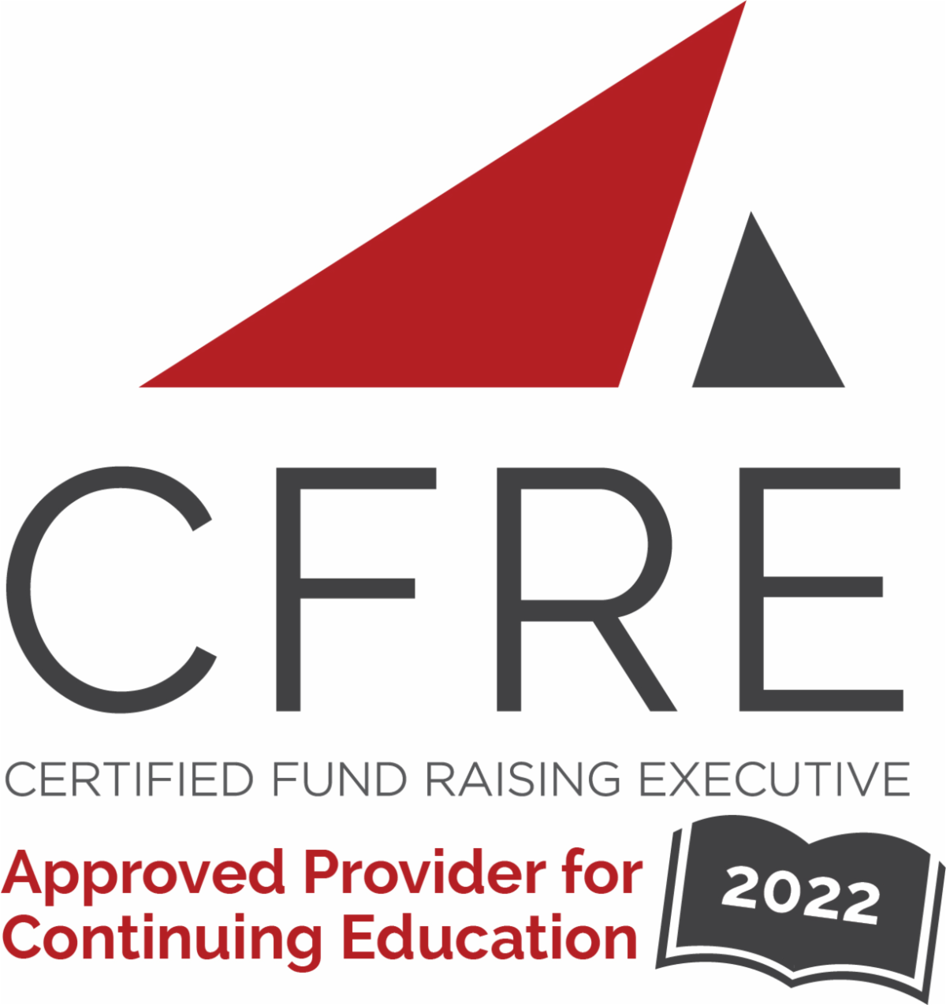  CFRE International has developed this form as a way for you to quickly track (and keep in your files!) the continuing education sessions you have attended. Simply check the boxes next to the sessions you attended. At the end of the conference, add up the total number of hours. Keep this sheet and you will be ready to complete your application form. All of the session slots listed are eligible for continuing education points on your CFRE application for initial certification and/or recertification. Sessions not listed here are not eligible for points. | CONTINUING EDUCATION POINTS TRACKER

Activity Organizer: - ACF
Title of Activity: - ACF 2022-2023 Webinars
Names of Presenter(s): - Various
Dates and Location: - Various, Online

Date: 20 January, 2022
12:30 pm – 1:30 pm (1.0 pts)
- Lessons Learned About the Annual Fund During a Worldwide Crisis - Anthony Alonso

Date: 24 March, 2022
12:30 pm – 1:30 pm (1.0 pts)
- Key Pillars of Capacity Building That Will Impact Your Organization's Success! - Paul Dunne

Date: 30 June, 2022
12:30 pm – 1:30 pm (1.0 pts)
- Celebrate Good Times: Earned Media – Brian Gavin

Date: 15 September, 2022
12:30 pm – 1:30 pm (1.0 pts)
- Exploring Multigenerational Generosity – Beth McKinley

Date: 29 September, 2022
12:30 pm – 1:30 pm (1.0 pts)
- The Wow, Now, and How of Planned Giving - Brenda Moore and Jason Gerdes

Date: 27 October, 2022
12:30 pm – 1:30 pm (1.0 pts)
- From Crisis Crucible to Program Growth: Partnerships That Raise Long-Term Support - Chad McEachern and Susan Raymond

Date: 10 November, 2022
12:30 pm – 1:30 pm (1.0 pts)
- Storytelling Techniques That Drive Revenue Growth - Jennifer Miller

Date: 17 November, 2022
12:30 pm – 1:30 pm (1.0 pts)
- Understand Your Donors’ Brains to Get Better Results - Geoff Peters

Date: 1 December, 2022
12:30 pm – 1:30 pm (1.0 pts)
- Gratitude: A Crucial Part of Your Fundraising Plan – Paul Marsh

Date: 8 December, 2022
12:30 pm – 1:30 pm (1.0 pts)
- Sustainable Giving in the Subscription Economy - Dave Raley

Date: 30 March, 2023
12:30 pm – 1:30 pm (1.0 pts)
- Reduce Dependency on Year-End and Episodic Giving With AI Driven, Real-Time Modeling of Donor Sentiment - Michael Gorriarán

Date: 27 April, 2023
12:30 pm – 1:30 pm (1.0 pts)
- 3 Ways to Advance Your Fundraising Leadership This Year - Patton McDowell

Date: 25 May, 2023
12:30 pm – 1:30 pm (1.0 pts)
- The Current State of Donor Retention and What You Can Do About It - James Goalder

Date: 8 June, 2023
12:30 pm – 1:30 pm (1.0 pts)
- The Art of Appreciation: How to Build Strong Donor Relationships - Kristine Miller

Date: 22 June, 2023
12:30 pm – 1:30 pm (1.0 pts)
- The Fundamentals of Nonprofit Fundraising - Emily Dubay and Rich Duncan

Total number of points attained: ________

