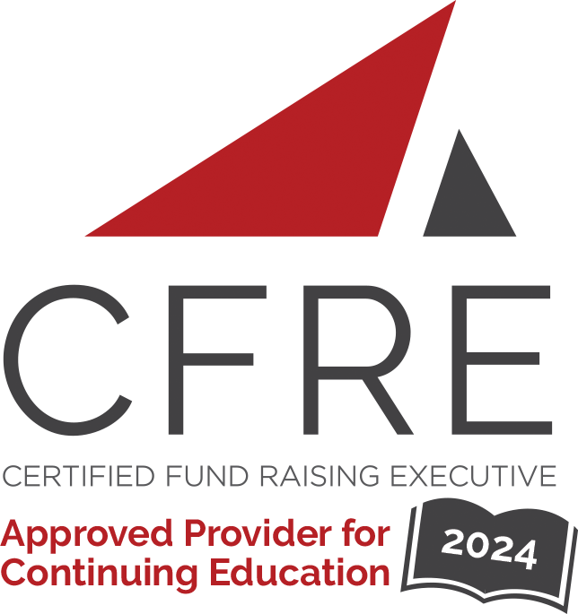  CFRE International has developed this form as a way for you to quickly track (and keep in your files!) the continuing education sessions you have attended. Simply check the boxes next to the sessions you attended. At the end of the conference, add up the total number of hours. Keep this sheet and you will be ready to complete your application form. All of the session slots listed are eligible for continuing education points on your CFRE application for initial certification and/or recertification. Sessions not listed here are not eligible for points. |  | CONTINUING EDUCATION POINTS TRACKER

Activity Organizer: - ACF
Title of Activity: - Faith & Fundraising: Myrtle Beach 2024
Names of Presenter(s): - Various
Dates and Location: - 26-29 February, 2024 – Myrtle Beach, SC USA

Date: 26 February, 2024
Session 1: 2:30pm – 4:30pm (2 pts)
- Donorarc Storytelling Part 2: Sharing Beyond the Obvious
- Norms, Narratives, and Numbers – How do we Respond to Current Giving Trends?

Date: 27 February, 2024
Session 2: 8:30am – 9:30am (1 pt)
- Keynote: A Return to Love and Generosity: Reflections for Faithful Fundraisers

Date: 27 February, 2024
Session 3: 10:00am – 11:15am (1.25 pts)
- Flipping the Fundraising Coin, Side 1: Fundraising Data
- Securing Significant Gifts from Wealthy Individuals
- Do You Believe in Miracles?
- Making Sense of “Faith” in Faith-Based Fundraising
-Storytelling Showdown: Unleash the Power of Your Story
-Managing Through Change – Building a Rockstar Development Team
-The Innovation Room: Finding Creative Solutions to Your Biggest Fundraising Challenges
- Continuing the Conversation: Reflecting on “A Return to Love and Generosity”

Date: 27 February, 2024
Session 4: 12:00pm – 1:00pm (1 pt)
- Keynote: How AI Is Transforming Fundraising and Marketing

Date: 27 February, 2024
Session 5: 1:30pm – 2:45pm (1.25 pts)
- Flipping the Fundraising Coin, Side 2: Elevating Donor Relationships
- Understanding Donor Motivation: How to Grow Giving When You are Already #1 in Hearts and Minds
- Doing This One Thing That Most Nonprofits Ignore Could Double Your Online Revenue Without Doing More
- Good to Great in 5 Years: What do Nonprofit Ministries with the Largest Fundraising Leaps Have in Common?
- Am I Guilting People to Give, or Guiding Them to Giving Decisions?
-Financial Advice and Generosity; How to Find Common Ground and Secure More Gifts
-Expand Your Audience – A Guide to Maximizing Faith-Based Holidays
- Why Oprah Should Not be on Your Prospect List: How to Inspire Board Members to be Better Fundraisers

Date: 27 February, 2024
Session 6: 3:15pm – 4:30pm (1.25 pts)
- Get Smart About Tax-Smart Giving in 2024
- The Philanthropic Hierarchy: Essential Organizational Features Key to Fundraising Success
- Fundraising From Congregations (Yes, it’s Worth It!)
- What Your Donors Won’t Tell You, But I Will!
- My Fundraising Conversion: A Guide for the Reluctant Fundraiser
-Mining Your Database to Find New Gifts and Donors
-Digital Fundraising in 2024: Elevating Your Nonprofit’s Impact in Our Distracted World
- The Innovation Room: Finding Creative Solutions to Your Biggest Fundraising Challenges

Date: 28 February, 2024
Session 7: 8:30am – 9:30am (1 pt)
- Keynote: It’s Not (Just) About the Money: Cultivating Deep Donor Relationships Through the Lens of Love

Date: 28 February, 2024
Session 8: 10:00am – 11:15am (1.25 pts)
- Strategic Planning in a Climate of Rapid Change: Congregations and Small Nonprofits
- Ministry on a Mustard Seed: Tips and Tools for Raising Big Gifts on a Small Budget
- Perk Up Your Annual Appeal with Fresh Ideas
- The Responsive Mindset
- Effective Prospect Management: Optimizing Your Approach to Raise More Major Gifts
-It’s Not (Just) About the Money: Cultivating Deep Donor Relationships Through the Lens of Love
- How AI is Transforming Fundraising and Marketing, Part II
-The Innovation Room: Finding Creative Solutions to Your Biggest Fundraising Challenges

Date: 28 February, 2024
Session 9: 11:30am – 12:30pm (1 pt)
- Keynote: Navigating the Next: Insights and Strategies for Nonprofit Success

Date: 28 February, 2024
Session 10: 2:00pm – 3:15pm (1.25 pts)
- Unlocking the Power of AI: How Fundraising Professionals Can Leverage Artificial Intelligence for Success
- Best Practices for Leading Your Organization Through Successful Digital Projects
- Embracing Change: Successful Strategies for Nonprofit Leaders and Fundraisers
- Engaging Volunteers as Donors
- Bottom Line Fundraising: Strategies for Major Gift Success
-Fluid Mechanics and Fundraising: Reduce Friction Loss, Master Your Daily Activities, Meet Your Goals!
- Ring, Ring… Cha-Ching… Use the Power of the Telephone in Your Fundraising Donor Retention Plan

Date: 28 February, 2024
Session 11: 3:45pm – 5:00pm (1.25 pts)
- Seven Keys to Building a Highly Effective Board: What Every Nonprofit Leader Needs to Know
- Grant Readiness for Faith-Based Organizations
- The Box is Just the Beginning!
- Wired for Success: Redefining Marketing Strategies Through Digital Transformation
- Give Room for God to Work in Your Fundraising Profession
- Data and Frontline Fundraising: A Collaborative Relationship for Success

Date: 29 February, 2024
Session 12: 9:00am – 11:00am (2 pts)
- Closing Session: Conclusions from the Big 3 Challenges and Keynote Panel

Total number of points attained: _________

